**Request for P r o p o s a l t o Purchase**

**Property Known as the “Upper Girard Lake”**

**October 20, 2020**

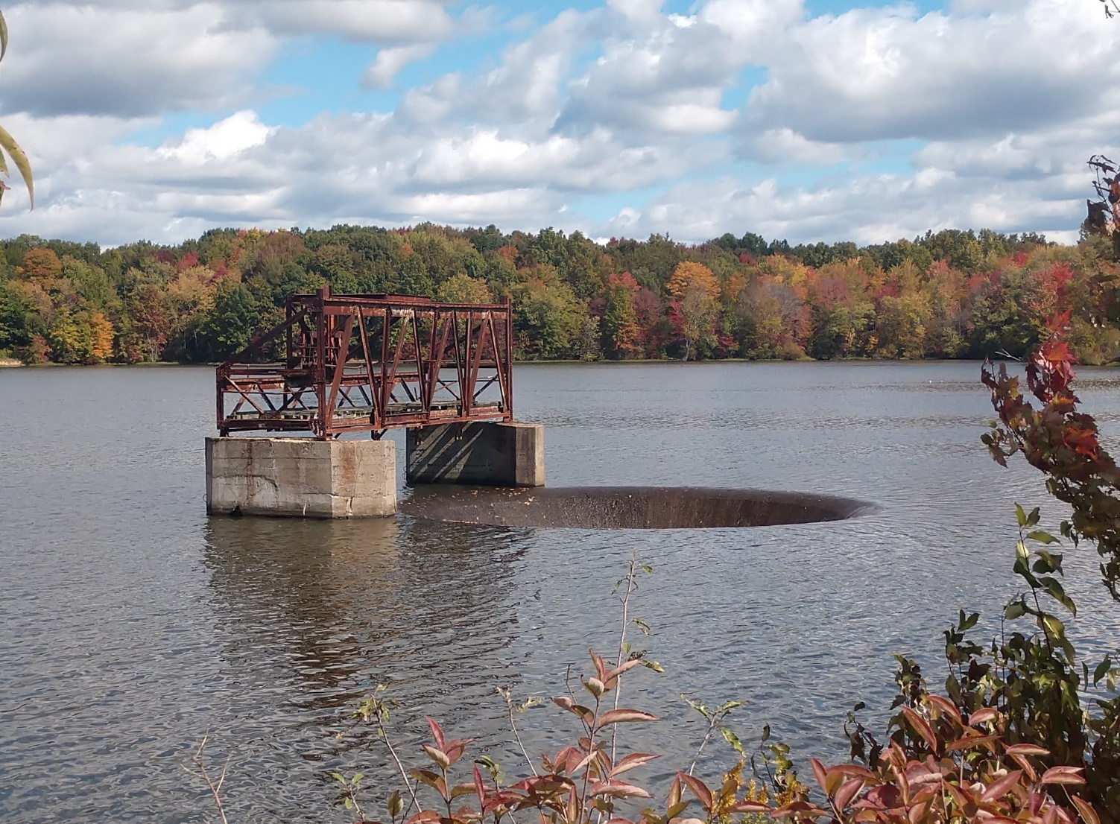

Upper Girard Lake Property

Upper Girard Lake Morning Glory Spillway

Director of Public Service

Girard City Hall

100 West Main Street

Girard, Ohio 44420

Contact: Dennis P. Meek, PE

[dennispmeek@gmail.com](mailto:dennispmeek@gmail.com)

Cell Phone: (216) 316-6847

## REQUEST FOR PROPOSAL FOR SALE OF REAL ESTATE

## City of Girard Upper Lake Property

**Introduction**

The City of Girard is soliciting proposals to purchase excess City owned land for development within the Squaw Creek Drainage Basin of the City of Ohio. The property is unique in the region as a large well-preserved watershed protection property and surface water storage lake and dam for a former industrial water supply source, which it is no longer needed. The purchaser will have a great opportunity to create a development of his own choosing in cooperation with the City of Girard and the State of Ohio and Trumbull County regulatory agencies and departments.

The land is currently zoned (public service) and the City is willing to work closely with the purchaser to plan for the best and highest use of the total property. An attractive residential development that complements the surrounding land uses and takes advantage of a unique park like setting, environmental preservation areas and potential recreational uses associated with the 175-acre Upper Girard Lake would be the ideal type of development.

This Request for Proposal (RFP) consists of text sections describing the basic information, submittal requirements and schedule for the submittal of a “Proposal to Purchase the Upper Girard Lake Property”. The RFP has Exhibits included. These Exhibits provide supplemental Information. References will be made to a list of “Attachments”, which are key documents needed to understand and evaluate the property. These Attachments are located on the City of Girard Web Site (cityofgirard.com) and may be downloaded in pdf format.

## Property Description and Special Conditions

The property consists of 728 total acres of wooded and partially open land, including the 175-acre Upper Girard Lake and the Upper Girard Lake Dam, complete. The City of Girard is selling this property under ORC Section 721, because the land, lake and dam are no longer needed for public purposes.

The property is comprised of Trumbull County Parcel Numbers 14-607649, 15-000001 and 15-000002, in the City of Girard, Ohio. The property was formerly part of Liberty and Vienna Townships. The three contiguous irregularly shaped parcels contain 728.19 acres. It is surrounded by State Route 11 to the southwest, Niles Vienna Road to the northwest, Smith Stewart Road to the northeast, Pleasant Valley Road to the east, Oriel Rogers Road to the southeast, and Anderson Morris Road to the south. Refer to **EXHIBIT No. 1: Aerial View of Upper Girard Lake Property and** ***ATTACHMENT NO.1: Upper Girard Lake Property Descriptions & Mapping*** *(download from cityofgirard.com web site).*

Niles-Vienna

Road

Anderson -Morris Road

SR-11



Pleasant Valley Road

EXHIBIT No. 1: Aerial View of Upper Girard Lake Property

***ATTACHMENT No. 2***: ***Final Upper Girard Lake Property Appraisal*** was prepared by Tricomi & Associates in 2018. This appraisal was authorized by the City of Girard to provide an opinion of the “As Is” market value for the property. This appraisal contains much additional information regarding the Upper Girard Lake Property and a complete copy is available on the city of Girard web site (cityofgirard.com)

The improvements to the site include four (4) producing gas wells, the 175-acre lake, the Upper Girard Lake Dam and spillway. The Upper Girard Lake Dam and spillway are 90 years old and impound the waters of the Squaw Creek to form Upper Girard Lake. The dam and spillway represent the major features of the property.

The dam consists of a rolled earth embankment, approximately 2,720 feet in length with a maximum height of 55 feet. The principal spillway is a 40-foot diameter morning glory type riser spillway, which discharges into a 17.5-foot arched discharge conduit that flows into the “plunge pool” at the base of the dam. The dam and principal spillway were constructed in the period from 1929 through 1932 by the Ohio Water Service Company (now Aqua Ohio, Inc.) for the purpose of surface water storage for their industrial raw water supply to the steel manufacturing facilities in Girard.

This Upper Girard Lake Dam was paired with the downstream Lower Girard Lake (aka Liberty Lake) Dam, spillway and water impoundment to provide the complete Ohio Water Service industrial water supply system. The city purchased the two lakes, related facilities and the watershed properties surrounding the lakes in 1995, with the intention of constructing a water treatment facility and distribution improvements to supply finished water to their 6,000-customer water service area. The option of an on-site water treatment facility was abandoned in the late 1990’s due to increasing costs, an ODNR mandate to rehabilitate the 1919 dam and a lack of economic feasibility.

The Girard Lakes Dams are regulated by the State of Ohio under provisions of the Ohio Revised Code and through the authority granted to the Ohio Department of Natural Resources (ODNR). The Lower Lake Dam was breached in 2004 and the Lower Girard Lake drained in order to satisfy safety and structural issues plus other requirements of the ODNR . The breach was completed in cooperation with the ODNR, the US Army Corps of Engineers and the Ohio Environmental Protection Agency. The Upper Girard Lake Dam and lake remain in service and are still under the regulatory jurisdiction of the ODNR.

**ODNR Safety Issues & Obligations of the Upper Girard Lake Dam Owner (Purchaser)**

***ATTACHMENT No. 3: Upper Girard Lake Dam Safety Inspection Report*** is the most recent ODNR dam safety inspection report prepared after the May 4, 2016 ODNR inspection. ODNR inspects the Girard Lake Dam once every 5 years and produces a Dam Safety Report dictating actions to be taken by the “Dam Owner” to bring the dam up to ODNR’s safety standards.

The May 4, 2016 ODNR Girard Dam Safety Inspection classifies the dam as a Class 1, which is the highest risk within Classes 1 to 4. Accordingly, remediations and repairs are mandated by ODNR in the report. Before placing the Upper Girard Lake Property on the market for sale, the City of Girard investigated the requirements associated with the transfer of all unsatisfied ODNR obligations to any potential new owner of the property including the Upper Girard Lake Dam.

The ODNR will only allow for the sale of the dam as part of the total property provided that the current owner, the City of Girard, provides for “full disclosure” of the current “Required Remedial Measures**,”** and that the purchaser provides written assurance that the required remedial measures and any future ODNR requirements will be completed to the satisfaction of the ODNR and the City of Girard**. EXHIBIT No. 2** presented below is an “excerpt” from **ATTACHMENT No. 3, Section 1. Required Remedial Measures.**

**Exhibit No 2**

(Reference: Section 1 of ATTACHMENT No. 3: The ODNR 2016 Upper Girard Lake Dam Safety Inspection Report)

**“Required Remedial Measures”**

*The requirements listed below are based on observations made during inspection, calculations performed, and requirements of the Ohio Administrative Code (OAC). A checklist noting all observations made during the inspection has been enclosed in Section 3. References to right and left in this report are oriented as if you were standing on the dam crest and looking downstream.*

***Engineer(ed) Repairs and Investigations:*** *The owner must retain the services of a professional engineer to address the following items. Plans, specifications, investigative reports, and other supporting documentation, as necessary, must be submitted to the Division of Water Resources for review and approval prior to construction. These items have been noted previously and the appropriate time period* ***for completion has already been exceeded.*** *A record of all repairs should be included in the operation, maintenance, and inspection manual.*

1. *The dam's discharge/storage capacity must be sufficient to safely pass the required design flood. Perform a hydrologic and hydraulic study to determine the adequacy of the dam's discharge/storage capacity to safely pass the required design flood. Prepare plans and specifications as necessary to increase the discharge/storage capacity to pass the required design flood. In accordance with OAC Rule 1501:21-13-02, the minimum design flood for Class I dams is 100 percent of the Probable Maximum Flood or the critical flood. See the Flood Routing Summary in Section 2 of this report for additional information.*
2. *This dam must have an emergency spillway in accordance with OAC Rule 1501:21-13-04. Prepare plans and specifications for the installation of an emergency spillway.* ***This item should be completed in coordination with Item 1 above.*** *See Discussion Item A included in this section for additional information.*
3. *The lake drain must operate properly and safely. Investigate the integrity of the sluice gates and the outlet pipe. Prepare plans and specifications for the repair of the gates and outlet pipe. See the "Lake Drains" fact sheet included in this section for additional information.*
4. *The lake drain must be accessible for operation and inspection. Prepare plans and specifications for replacement of the lake drain access structure. See the “Lake Drains" fact sheet included in this section for additional information.*
5. *The discharge tunnel must be repaired. Prepare plans and specifications for the repair of all spalling on the interior and exposed exterior portions of the principal spillway outlet pipe and for resealing the spillway joints. Monitor the joints in the principal spillway discharge tunnel quarterly for loss of sealant until repairs are made. See the "Spillway Conduit System Problems" and "Problems with Concrete Materials" fact sheets included in this section for additional information.*
6. *The embankment drain system must function properly. Due to the age of the embankment drain system, the questionable construction materials, and the inability to monitor the outflow, the entire embankment drain system must be investigated by a registered professional engineer to determine the functionality, suitability, and adequacy of the embankment drain system. As necessary, prepare plans and specifications for the repair or modification of the embankment drain system. See Discussion Item B and the "Seepage Through Earthen Dams" fact sheet for additional information.*
7. *A geotechnical engineer must inspect the piezometer on the downstream toe of the southwest embankment to determine if it is operable, if it is needed, and an appropriate reading schedule. All the necessary repairs must be made. See Discussion Item C included in this section for additional information.*

***Owner Repairs:*** *The owner must address the following items. The owner may hire a contractor or perform the work him or herself. Repair activities should be documented in the operation, maintenance, and inspection manual.*

*1****.*** *Remove the trees and brush from the upstream slope, the entire west embankment, and the left end of the south embankment. Seed all disturbed areas to establish a proper grass cover. See the ''Trees and Brush" fact sheet included in this section for additional information.*

1. *Once the dam has been cleared of trees and brush, seed all embankments to establish a proper grass cover. See the "Ground Cover" fact sheet included in this section for additional information.*
2. *Repair the displaced slope protection on the upstream slope. See the “Upstream Slope Protection" fact sheet included in this section for additional information.*
3. *Repair the erosion gully on the left groin of the downstream slope of the south embankment. See the "Ground Cover" fact sheet included in this section for additional information.*
4. *Repair the deep ruts on the crest and downstream slope at the left end of the south embankment. See the "Ground Cover" fact sheet included in this section for additional information.*
5. *Repair the deterioration on the principal spillway discharge tunnel. See the "Spillway Conduit System Problems" and "Concrete Repair Techniques" fact sheets included in this section for additional information.*
6. *Replace the staff gauge that was located on the lake drain inlet structure. Please note that the graduations should extend below the normal pool level to allow monitoring during drawdowns. See Discussion Item D included in this section for additional information.*

***Owner Dam Safety Program:*** *In accordance with Ohio Revised Code (ORC) Section 1521.062, the owner of a dam shall maintain a safe structure and appurtenances through inspection, maintenance, and operation. A dam, like any other part of the infrastructure, will change and deteriorate over time. Appurtenances such as gates and valves must be routinely exercised to ensure their operability. Inspection and monitoring of the dam identify changing conditions and problems as they develop, and maintenance prevents minor problems from developing into major ones. Dams must have these procedures documented in an operation, maintenance, and inspection manual.*

*Despite efforts to provide sufficient structural integrity and to perform inspection and maintenance, dams can develop problems that can lead to failure. Early detection and appropriate response are crucial for maintaining the safety of the dam and downstream people and property. The ORC requires the owner to fully and promptly notify the Dam Safety Program of any condition which threatens the safety of the structure. A rapidly changing condition may be an indication of a potentially dangerous problem. The Dam Safety Program can be contacted at 614/265-6731 during business hours or at 614/799-9538 after business hours. Dam owners must have emergency preparedness procedures documented in an emergency action plan.*

*The owner must address the following items:*

* 1. *Once the ruts have been repaired on the crest (of the Dam) and downstream slope at the far-left end of the south embankment, monitor the area quarterly for any reoccurrence of a wet area. See the "Seepage Through Earthen Dams”, fact sheet included in this section for guidance in monitoring for seepage and for additional information.*
  2. *Until repairs can be made, monitor the deterioration of the principal spillway discharge tunnel quarterly for further deterioration. See the “Spillway Conduit System Problem”, "Concrete Repair Techniques", and “Problems with Concrete Materials" fact sheets included in this section for guidance in monitoring the spillway system and for additional information.*
  3. *Monitor the erosion around the sides of the plunge pool quarterly for add optional erosion, sloughing, or slope instability. See the “Outlet*

*Erosion Control: (Stilling Basins)'' fact sheet included in this section for guidance in monitoring the condition of the plunge pool and for additional information.*

* 1. *Monitor the leakage from the lake drain system quarterly for sudden increases in flow. See the “Lake Drains " fact sheet included in this section for guidance in monitoring the lake drain and for additional information.*
  2. *This dam must have an operation, maintenance, and inspection manual (OMI) in accordance with OAC Rule 1501:21-21-04. Prepare an OMI. Guidelines for the preparation of this document are included with this report.*

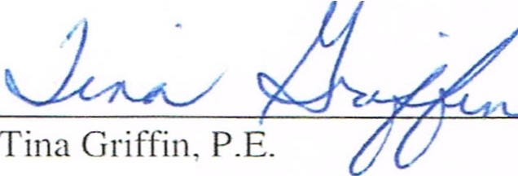

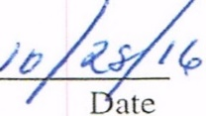

Project Manager Dam Safety Program

Division of Water Resources

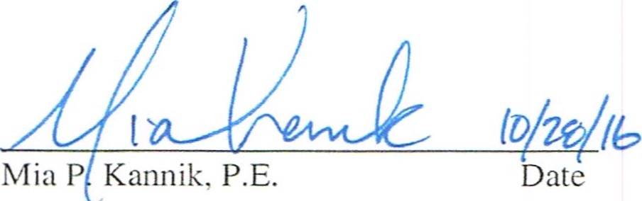This inspection was performed pursuant to the authority granted to the Chief of the Division of Water Resources in ORC Section 1521.062.

Program Manager

On behalf of Andrew D. Ware, Acting Chief Division of Water Resources

**END of EXHIBIT No. 2**

All proposers are required to review ***ATTACHMENT NO. 2*** in its entirety as part of the proposal development process. ***EXHIBIT No. 2*** has been made part of this RFP because of the critical importance of this aspect of the purchase conditions placed on the City of Girard by the ODNR.

The purchase proposal, as described below, shall include the required scope of work, preliminary estimates of construction and project cost, permitting requirements and schedule as prepared by an Ohio Registered Professional Engineer. Some of the required remedial measures have been addressed by the City of Girard. These improvements have not been submitted to or approved by ODNR and are subject to their final review and approval. The list includes:

1. The installation of a new accessible 24-inch lake drain valve. (The four (4) submerged existing 36-inch sluice gate drain valves have not been removed or renovated.)
2. The clearing of brush and small trees on the upstream face of the main dam embankment where the stone paving erosion control was initial placed has been completed. The extent of this clearing has not been approved by ODNR.

## Zoning

Zoning for the Upper Girard Lake Property is zoned “Public Service”, which may be revised to fit with the City of Girard Planning Commission approved proposed development and land use plan.

## Purchase Proposal and Future Development Plans

The city of Girard does not have a preferred development plan for the property. There are some required obligations for the dam repair, modification and maintenance, as described above, that will transfer to the new owner of the property. These obligations must be addressed as part of the purchase proposal and include a schedule for completion of all ODNR required modifications.

* The property development can be single-family detached owner- occupied housing, with some area developed as commercial, multi-family or recreational use. There is currently some agricultural use on the property. These options may be limited by the availability of water and sanitary sewer service. Water supply and sanitary sewer service area available.
* The entire site should provide s a minimum 30% open space, not including drives and parking. This can be achieved through normal setbacks or a combination of setbacks and consolidated open space.
* The proposal must contain a detailed plan and schedule for the successful resolution to both the owner directed and the engineered and constructed improvements to the dam per the most recent ODNR Dam Safety Inspection Report (2016), which is included as **EXHIBIT No. 2**, above and in **ATTACHMENT No. 3.**
* Additional proposal requirements are as described below.

## 

## Purchase Price

The city is prepared to sell the property “As Is” for no less than $4,350,000. The respondent (proposer) should state the cost they are willing to pay and it should be a minimum of $4,350,000. This “As Is” minimum purchase price was determined by using the Appraiser determined market value for the 728.19-acres would be $,8,000 per acre prior to the correction of the remedial dam issues mandated by ODNR. This equates to a dollar amount of $5,825,520. Please refer to Page 77 of ***ATTACHMENT NO. 2: The Upper Girard Lake Appraisal Report (2018).***

During the preparation of the appraisal a preliminary project cost estimate for bringing the dam into compliance with the ODNR remedial measures was developed by registered professional engineers. This cost in 2018 dollars was determined to be $1,476,000. This amount was subtracted from the $5,825,520 full appraisal amount to establish the “As Is” market value of the property at $ 4,350,000.

## Submission Requirements & Formats

* 1. Cover Letter. The cover letter should provide a summary of your proposed purchase proposal, a detailed presentation on the scope of work, preliminary design and costs required to mitigate the ODNR mandated remedial measures for the Upper Girard Lake Dam. The cover letter should also summarize the preliminary development plan based on the proposer’s intent. The summary statement included must also affirm that the Purchaser shall negotiate and enter into a “Purchase Agreement” with the City of Girard.
  2. The final purchase agreement shall include the terms of the purchase, and the transfer of all existing leases and easements. Additionally, the purchase agreement shall include the necessary terms and conditions required to **obligate** **the purchaser to plan, engineer and construct the necessary improvements to the Girard Lake Dam, as required by the Ohio Department of Natural Resources (ODNR).** The purchase agreement will not be entered into by the city of Girard without the plan approval of the ODNR.
  3. The proposed responders purchase timeline and land transfer structure, to be included in the future Purchase Agreement between the city of Girard and the Purchaser.
  4. Financial Terms, Conditions & Capacity: The selected proposer shall within 15 days of the notification by the City of the acceptance of his purchase proposal, deliver to the City a certified check in the amount equal to 10% of the amount of the Purchase Price. This amount shall be held as a cash bond for the final executation of the purchase agreement.
  5. The proposed purchaser shall submit with his proposal:
     1. A certified and notarized statement from a financial institution stating the ability of the proposer to furnish to the city the full amount of the purchase price at closing.
     2. Alternative means and methods of financing the purchase will be considered by the city only as an alternative to the payment in full at the time of closing.
     3. Proposals not including this information may be considered non-responsive.
  6. Discuss your experience in developing properties related to your proposal.
  7. Any assistance requested by the respondent from the City of Girard.
  8. Respondents (Proposers) must submit five (5) hard copies of their complete purchase proposal along with a digital form of the submittal in pdf format.

## Selection Process

The City of Girard Board of Control and the City Engineer will review and evaluate the responses to the RFP. During this process, the City may seek additional information for the responders. In addition, the City may request the responders to make a presentation of their proposal.

Only proposals received by the due date will be reviewed. Subsequent to the review, the City of Girard Board of Control will make its recommendation to the Girard City Council, Girard Law Director, Girard Planning and Zoning Commissions. The Girard City Council shall pass an ordinance designating who is the “selected responder” and permitting the Service Director to enter into negotiations on the final terms and conditions of the purchase agreement.

## 

## Schedule

The following schedule represents the anticipated timeline for the selection of the approved Proposal to Purchase the Upper Girard Lake Property. If the need arises, the schedule may be altered by the City of Girard. During this process, the City may seek additional information from the responders. In addition, the City may request the responders to make a presentation of their proposal.

RFP Schedule:

1. First Advertisement of RFP________________________10-20-2020
2. **Pre- proposal Meeting __________________________11-06-2020**
3. Last and Fifth Advertisement_______________________11-17-2020
4. Purchase Proposals Due at 3:00 PM________________ 12-08-2020
5. Select Most Responsive and Best Proposal___________12-22-2020
6. Begin Purchase Agreement Negotiations_____________12-28-2020

**”**.

## Proposal Evaluation

The City shall consider the following information when evaluating submitted proposals to determine which proposal is in the best interest of the City:

* Qualifications of the Respondents (Proposers)
* Financial benefit to the City of Girard, with consideration to amount offered and the plan to address the ODNR Mandatory Remedial Measure and Modifications to the Girard Lake Dam.
* The Proposer’s financial capacity to meet the requirements of the purchase.
* Time frame for completion of the plan to address the ODNR Requirements of the 2016 Upper Girard Lake Dam Inspection Report.

## Certification of Proposers

All Proposers must certify that they are not delinquent in the payment of real estate taxes or personal property taxes or City of Girard Municipal Income Tax.

## City of Girard Reservations

The City of Girard reserves the right to:

* Modify, waive or vary terms of the RFP at any time, including and not limited to submission deadlines, and proposal requirements,
* Reject any or all proposals,
* Cancel or withdraw the RFP at any time,
* Accept the proposal which best serves the interest of the City.

## 

## Project Information

With this property sale for possible future development, the City of Girard expects the Purchaser/Developer to be responsible for the preparation of all designs, plans and installations for the roadways, off street parking, water services, sanitary sewers or on-lot wastewater disposal systems, storm sewers, sidewalks, and street lighting in accordance with City of Girard and Trumbull County Specifications and Standard Drawings.

All of the aforementioned are considered the infrastructure. The Purchaser/Developer will enter into a private development/construction contracts for the Public Improvements, which will be dedicated as public infrastructure and maintained by the City of Girard.

Questions regarding the infrastructure requirements should be directed to City Engineer.

Other questions regarding Dam and Stream Hydraulic Calculations, Existing Upper Girard Lake Dam Construction Plans and Gas Well Information should also be directed to the City Engineer.

## Attachments Available on the City of Girard web site at (cityofgirard.com):

1. Upper Lake Property Legal Descriptions & Mapping
2. Final Upper Girard Lake Property Appraisal Report – 2018
3. ODNR Upper Lake Dam Safety Inspection Report - May 2016
4. Upper Girard Lake Dam Emergency Action Plan - 2010
5. Upper Girard Lake- Squaw Creek Hydraulic Analysis Report - 2014
6. Wetland & Watercourse Identification and Delineation Report -2014

## 

## Questions & Comments

All questions and /or Comments about this RFP should be directed to the Acting Girard City Engineer, Dennis P. Meek, PE at [dennispmeek@gmail.com](mailto:dennispmeek@gmail.com), Cell Phone: (216) 316-6847. Questions should be submitted in writing via e-mail between 9:00 AM and 5:00 PM Monday through Friday. Please allow up to 48 hours for a written response.

Director of Public Service

Girard City Hall

100 West Main Street

Girard, Ohio 44420

Contact: Dennis P. Meek, PE

[dennispmeek@gmail.com](mailto:dennispmeek@gmail.com)

Cell Phone: (216) 316-6847